- System Overview:
This system automates plant care and provides detailed plant health information. It integrates an ESP32 microcontroller with sensors, actuators, and a machine learning (ML) model. The mobile app (using Blynk) is designed for visually challenged users, featuring voice assistance and haptic feedback for accessibility.

- Architecture Overview

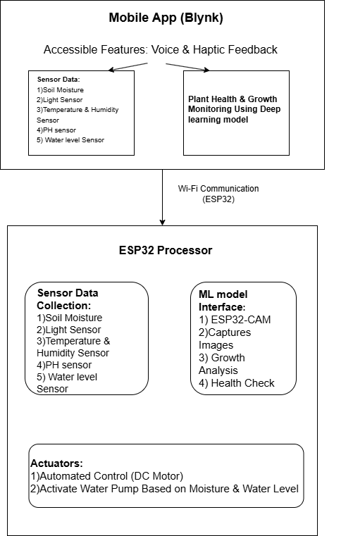
3. System Components

Hardware
1. Processor: ESP32 (main controller) and ESP32-CAM (for ML tasks).
2. Sensors:
- Soil Moisture Sensor: Monitors soil hydration.
- LDR (Light Sensor): Measures light intensity.
- Temperature & Humidity Sensor (DHT22): Records environmental conditions.
- Water Level Sensor: Monitors water tank levels.
- pH Sensor: Measures soil pH for nutrient assessment.
3. Actuator:
- DC Motor: Pumps water based on soil moisture and water level conditions.
4. Camera:
- ESP32-CAM: Captures images for health and growth monitoring.
5. Power Supply:
- Ensure sufficient power (5V for ESP32 and peripherals).

Software
1. Microcontroller Logic (ESP32):
- Data acquisition from sensors.
- Decision-making for watering and motor control.
- Communication with the Blynk app.
- Scheduled activation of ESP32-CAM for ML-based plant health checks.

2. Machine Learning (ML) Model:
- Model Type: Lightweight CNN (e.g., MobileNet) optimized with TensorFlow Lite.
- Functionality:
- Detect plant health (healthy, decayed, or dead).
- Analyze growth using color and size differences.
- Deployment: Use ESP32-CAM with TensorFlow Lite Micro.

3. Mobile App (Blynk):
- Displays sensor data (e.g., soil moisture, light intensity, pH, water level).
- Notifications for visually challenged users:
- Voice Assistance: Audio Messages to update the plant information to user.
- Haptic Feedback: Vibrations for Navigation.

4. Working Principle

Sensor Integration and Decision-Making:
1. Soil Moisture:
- If moisture drops below a set threshold, the DC motor pumps water.
- Stops when soil moisture is sufficient or the water level is low.

2. Water Level:
- Prevents water pump activation if the tank is empty.
3. Light Sensor:
- Tracks light exposure for plant health.
4. pH Sensor:
- Sends alerts if pH levels are unsuitable.
5. Temperature & Humidity Sensor:
- Sends alerts of temperature and Humidity of the plat environment .

Machine Learning Workflow:
1. Image Capture:
- ESP32-CAM captures plant images every 3–4 days.
2. Model Inference:
- Classifies plant health (healthy, decayed, or dead).
- Measures growth based on color and size.
3. Action:
- Sends plant health and growth reports to the app.

Blynk App:
Accessible Features:
Custom voice alerts for each metric.
Large, high-contrast buttons and simplified UI.
Widgets for:
Real-time data Monitoring.
Manual motor control (if needed).

